Carbon in life

About Carbon

The origin of the name ‘carbon’ is a Latin word ‘carbo’ which means charcoal. This may come as a surprise to you, but it is the fourth most abundant element in the entire universe. And it is the second most abundant element in our bodies, the first being [oxygen](https://www.toppr.com/guides/science/air-around-us/oxygen-in-air/). As a matter of fact, all organic substances in the world contain carbon in some form or element, which is why it is the base for the entire branch of organic [chemistry](https://www.toppr.com/guides/general-knowledge/basic-science/basic-chemistry/).

Carbon Atom

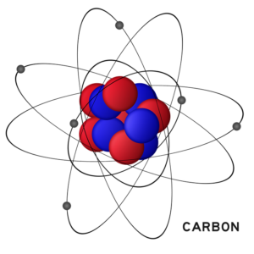

The atomic number of carbon is 6, which represents the number of electrons. It is represented by the symbol C and is a non-metal. It has 6 protons, 6 [neutrons](https://www.toppr.com/guides/chemistry/structure-of-atom/neutrons/) and obviously 6 electrons. A carbon atom is considered to be special and unique because it can bond with other carbon atoms to an almost unlimited degree. It is because its [atom](https://www.toppr.com/guides/chemistry/atoms-and-molecules/what-is-an-atom-and-how-do-atoms-exist/) is very small in size and can conveniently fit in as a part of larger molecules. Each of its atoms has four electrons in its outer shell called *valence electrons* and can form for chemical bonds with other atoms and [molecules](https://www.toppr.com/guides/chemistry/atoms-and-molecules/molecule-and-molecule-of-elements/).

Physical Properties of Carbon

The physical properties of this element vary according to its allotropes. The two major allotropes are diamond and graphite. These two have almost opposing physical properties.

* Whereas diamond is transparent and has no colour, graphite is opaque and black
* Diamond is the hardest substance known to man, graphite is soft and spongy in texture
* Now diamond cannot conduct electricity at all, graphite is a very good conductor of electricity
* Both allotropic elements are solid, non-gaseous
* Also both diamond and graphite are insoluble in water
* It does not melt when heated, it sublimes which is it turns to gaseous form

Uses of Carbon in daily life

Now you may not even notice but carbon is used in so many daily activities. Some of the most important uses are:

* It makes up for 18% of the human body. Sugar, glucose, proteins etc are all made of it. The food we eat contains an important source of energy which we call carbohydrates. Carbohydrates are nothing but elements of carbon itself.
* Carbon in its diamond form is used in jewellery. But diamonds are also used for industrial purposes. It is the hardest substance known to man and so has many uses in manufacturing processes.
* Amorphous carbon is used to make inks and paints. It is also used in batteries.
* Graphite is used as the lead in your pencils. It is also used in the production of steel.
* One of the most important uses is *carbon dating.*We can actually use carbon to measure the age of things. Scientists use a rare form of carbon called Carbon-14 to measure the age of fossils, bones etc. The release of this carbon-14 is recorded to estimate the life of the said organic substance. This is how scientists find the age and period of dinosaur bones and fossils

Types of Carbon Compounds

### 1. Saturated Carbon Compounds

These are the compounds in which various carbon atoms in a chain or a ring are linked together by ***single bonds*** ***only***. Alkanes are the most common examples of saturated chain carbon compounds. Ethane is a member of the alkane family whose structure is drawn below:



### 2. Unsaturated Carbon Compounds

These are the compounds in which various carbon atoms in a chain or a ring are linked together by ***double or triple bonds.*** [Alkenes](https://byjus.com/chemistry/chemical-properties-of-alkenes/) (where carbon atoms are linked through double bonds) and alkynes (where carbon atoms are linked through triple bonds) are the most common examples of unsaturated chain carbon compounds. Ethene is a member of the alkene family whose structure is drawn below:

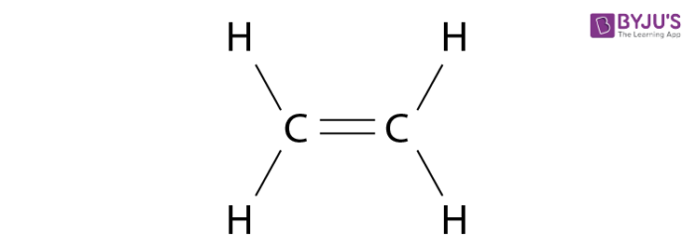

**What are the Versatile Features of Carbon?**

Carbon has two basic natures which make it the most extensively present element in organic compounds. These are catenation and tetravalent nature.

1. **Catenation**

Each and everything is surrounded by carbon compounds in the field of Organic Chemistry. Carbon compounds are one of the quintessential components of living organisms. Carbon consists of two stable isotopes namely 12C and 13C. Apart from these two isotopes there is another isotope of carbon existing in nature. It is 14C. Radiocarbon dating is done by the carbon and it is also a radioisotope with a half-life of 5770 years.

* One of the most unique properties of carbon is that it is able to make long carbon chains and rings. This unique feature of carbon is termed as catenation.
* Another amazing property of carbon is that carbon forms p-pπ bonds which are double and triple bonds with itself and with other electronegative atoms such as oxygen and nitrogen.
* Carbon has a number of allotropic structures just because of these two properties of carbon i.e. catenation and multiple bond formation.

The small size of the carbon atom and the carbon-carbon bond strength enables it to form stable multiple bonds too with itself and other element atoms. Propane and butane are two such straight-chain elements while 2-methylpropane and 2,2-dimethylpropane are two branched-chain elements. Cyclohexane and cyclobutane are two ring-structured elements.

1. **Tetravalent Nature**

This enables carbon bonds with four atoms of carbon itself or atoms of other elements with the help of a single, double or triple bond.

What does the Allotrope of Carbon Actually Mean?

If an element is present in nature in various forms with various physical properties and similar chemical properties then its forms are termed as allotropes of allotropic forms. Two or more physical forms of one element actually define allotropes. Allotropes are formed on the basis of carbon atoms but exercise different physical properties, mainly with regard to hardness.

Diamond and graphite are the two most common crystalline allotropes of carbon. Recent researches reveal that all the amorphous carbons consist of microcrystal of graphite. In spite of the difference in the crystal structure and physical properties of these allotropes, their chemical properties are the same. Diamond and graphite bear the symbol C and both release carbon dioxide when strongly heated in the presence of oxygen.

What are Some Important Carbon Compounds?

Ethyl alcohol or ethanol and ethanoic acid are two of the most important carbon compounds.

1. **Ethanol**

Its chemical formula is CH3CH2-OH or C2H5OH. It is a colorless inflammable liquid that, when added to water, forms a homogeneous mixture in all proportions. Litmus paper does not change color when brought in contact with ethanol.

**Some of its chemical properties are as follows:**

1. It reacts with sodium to form sodium ethoxide
2. Ethanol reacts with concentrated H2SO4 which removes water from ethanol.

**2.   Ethanoic Acid**

This is commonly known as acetic acid with the chemical formula CH3COOH. When 5-8% of ethanoic acid is mixed with water, it is known as vinegar. Ethanoic acid freezes in an extremely cold climate and its melting point is 290K. Thus, it is also called glacial acetic acid. It is a pungent-smelling liquid devoid of any color. It is miscible with water and turns blue litmus red.

**Some of its Chemical Reactions are as Follow:**

* In the presence of concentrated H2SO4, ethanoic acid reacts with alcohol to give off a sweet-smelling ester. This is known as the esterification reaction.
* Ethanoic acid reacting with sodium carbonate or sodium bicarbonate produces carbon dioxide, water and sodium ethanoate salt.

Uses of carbon and its compounds

* Carbon is **the basic building block of life.**
* Hydrocarbons are the compounds of carbon and hydrogen are the major source of fuel.
* Carbon based compounds like ethylene, polypropene, polystyrene etc. are widely used in polymerisation process.
* They are used in the synthesis of many dyes and drugs.
* Diamond is a allotrope of carbon used for cutting marble, granite and glass, it is also used for jewellery.
* Graphite  is used to make electrodes for electrolytic cells, for making pencils, lubricates for machines.
* Glucose  is made of carbon , hydrogen and oxygen used is the main source of fuel for our cells

Uses of Sucrose

Some of the important uses of this compound are listed below.

* Sucrose is one of the most important components of soft drinks and other beverages.
* This compound is used in many pharmaceutical products.
* It serves as a chemical intermediate for many emulsifying agents and detergents.
* It also serves as a food thickening agent and as a food stabilizer.
* The shelf lives of many food products, such as jams and jellies, are extended with the help of this compound.
* The use of sucrose in baking results in the brown colour of the baked products.
* This compound also serves as an [antioxidant](https://byjus.com/chemistry/antioxidants/) (a compound that inhibits oxidation).
* Sucrose is widely used as a food preservative.

Uses of Ethanol

* Owing to its antibacterial and antifungal properties, ethanol (also known as ethyl alcohol) is used in many hand sanitizers and medical wipes.
* Ethanol is also used as an antiseptic and as a disinfectant.
* In cases of ethylene glycol poisoning or methyl alcohol poisoning, ethanol is often administered as an antidote.
* Several medications that are insoluble in water are often dissolved in ethanol. For example, ethanol (in concentrations ranging from 1% to 25%) is used as a solvent for some analgesics and mouthwashes.
* Ethanol is the primary ingredient in many alcoholic drinks that are orally consumed for recreational purposes. It acts as a psychoactive drug by reducing anxiety and creating a feeling of euphoria in Humans. However, it also impairs cognitive and motor functions and acts as a central nervous system (CNS) depressant.
* Ethanol is used industrially in the production of ethyl esters, [acetic acid](https://byjus.com/chemistry/acetic-acid/), diethyl ether, and ethyl amines.
* This compound is widely used as a solvent due to its ability to dissolve both polar and nonpolar compounds.
* Since it has a melting point of -114.1oC, ethanol is used as an ingredient in cooling baths in several laboratories. It also serves as the active fluid in many spirit thermometers.

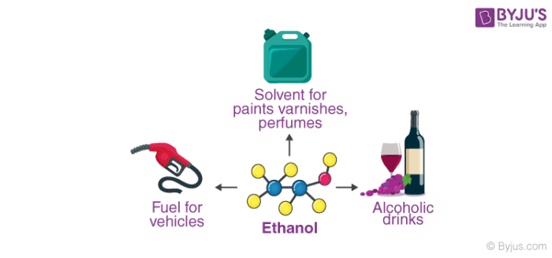

Uses of Ethanol as a Fuel

Ethanol is widely used as a fuel additive and as an engine fuel. Some forms of gasoline are known to contain up to 25% ethanol. This compound has also been used as rocket fuel in some bipropellant rockets. When used in fuel, ethanol is believed to reduce carbon monoxide and nitrogen oxide emissions.

Since it is widely available and has low toxicity and cost, ethanol is used in direct-ethanol fuel cells (or DEFCs). However, commercially used fuel cells generally use methanol, hydrogen, or natural gas.

Uses of Methanol

* Methanol is widely used in the production of acetic acid and formaldehyde.
* In order to discourage the recreational consumption of ethanol, methanol is often added to it as a denaturant.
* This compound is also used as an antifreeze (an additive that is used to lower the freezing point of a liquid) in many pipelines.
* It is also used in sewage treatment plants since it serves as a carbon-based food source for denitrifying bacteria.
* The polyacrylamide gel electrophoresis (PAGE) technique involves the use of methanol as a destaining agent.
* A mixture of water and methanol is used in high-performance engines in order to increase power.
* Methanol is used in the production of hydrocarbons, olefins, and some [aromatic compounds](https://byjus.com/chemistry/aromatic-compounds/).
* It is also used in the production of methyl esters and methylamines.

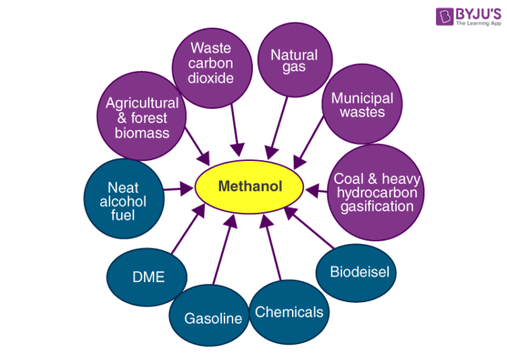

Uses of Methanol in Fuel

Methanol can be used as a fuel in several internal combustion engines. The chemical equation for the burning of methanol is given by:

**2CH3OH + 3O2 → 4H2O + 2CO2**

However, the primary disadvantage of methanol as a fuel is that it has a tendency to corrode aluminium and some other metals. Another shortcoming of methanol as a fuel is that its energy density is approximately half of the energy density offered by gasoline.

An advantage of methanol as a fuel is that it is relatively easy to store. The storage of liquid methanol is much easier than the storage of hydrogen gas or natural gas. Other merits of this compound include its biodegradability and its short half-life in groundwater.

Uses of Ethanoic Acid

1. Ethanoic acid is widely used in many industries.
2. Commercially it is used in the manufacturing of esters, vinegar, and many polymeric materials.
3. Vinegar has been shown to reduce high concentrations of blood sugar.
4. Used as an agent to lyse red blood cells before white blood cells are examined.
5. Used as a solvent in the production of camphor, ascent and cooking ingredient.
6. Used as a stop bath for photographic emulsion development.
7. Farmers sometimes spray acetic acid on livestock silage to fight fungal and bacterial growth.

Petroleum

**Petroleum** formed from theremains of dead organisms that fell to the ocean floor, and wereburied under thick sediment. High pressures slowly converted them to petroleum, over millions of years

Petroleum is referred to as ***“Black Gold.”*** This name itself is an indication of its importance to humans. Crude oil is considered to be the ***“mother of all commodities”*** as it is used to manufacture various products such as pharmaceuticals, plastics, gasoline, synthetic fabrics, etc. Petroleum or oil has also been the world’s leading source of energy since the 1950s.

Petroleum is a liquid which occurs naturally in rock formations. This consists of a complex mixture of different molecular weights of hydrocarbons, plus other organic compounds. Some petroleum-produced chemical compounds are also obtained from other fossil fuels.

Petrochemicals are produced mainly at a few manufacturing sites around the world. Petroleum is also the raw material for many industrial products, including pharmaceuticals, solvents, fertilizers, pesticides, synthetic fragrances, and plastics.

### Petroleum

Petroleum Meaning

The word petroleum translates to ***“rock oil.”*** It is derived from the Greek word **“petra”** and the Latin word “oleum”. When it is drilled from the ground in the liquid form, it is called crude oil. Humans have known about its existence for 4000 years. However, the first time crude oil was pumped from the ground was 2500 years ago in China and the ***world’s first crude oil well was drilled in Pennsylvania, USA*** only in the year 1859.

Petroleum or mineral oil is India’s next biggest source of energy after coal. It supplies heat and lighting power, machinery lubricants, and raw materials for a variety of manufacturing industries. Petroleum refineries for synthetic textiles, fertilisers and numerous chemical industries act as a “nodal industry.” Most of India ‘s petroleum occurrences are associated with anticlines and fault traps in tertiary-age rock formations. It occurs in folding regions, anticlines, or domes, where oil is trapped in the unfolded crest.

How is Petroleum Formed?

* + - * Petroleum is formed from the remains of dead plants and animals.
      * When plants and animals die, they sink and settle on the seabed.
      * Millions of years ago, these dead wildlife and vegetation decomposed and got mixed with sand and silt.
      * Certain bacteria helped in the decomposition of this organic matter and caused some [chemical changes](https://byjus.com/chemistry/chemical-physical-change/).
      * Matter consisting largely of carbon and hydrogen was left behind. However, as there is no sufficient oxygen at the bottom of the sea, the matter could not decompose completely.
      * The partially decomposed matter remained on the seabed and eventually was covered with multiple layers of sand and silt.
      * This burying took millions of years, and finally, due to high temperature and pressure, the organic matter decomposed completely and formed oil.

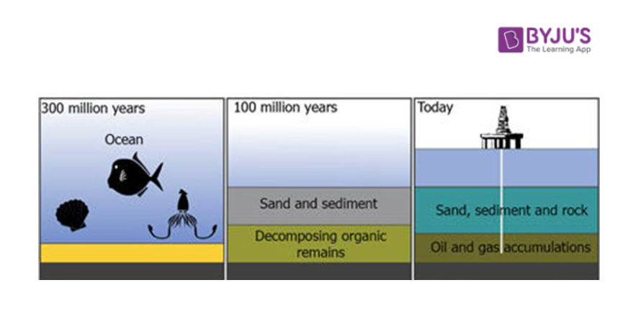

Petroleum-Refining

Petroleum refineries are very large industrial complexes involving a great many processing units and auxiliary installations such as utility units and storage tanks. That refinery has its own specific arrangement and combination of processes for refining largely dictated by the location of the refinery, the target products and the economic considerations.

An oil refinery or petroleum refining is an industrial manufacturing facility where crude oil is extracted and converted into more valuable goods, such as petroleum naphtha, gasoline, jet fuel, asphalt foundation, heating oil, petroleum kerosene, and liquefied gas. Oil refineries are usually huge, vast industrial facilities with extensive pipelines running throughout, holding fluid streams in between.

* + - * Petroleum is a mixture of many substances such as gas, petrol, diesel, kerosene, lubricating oil, paraffin wax, etc.
      * As these constituents serve different purposes, it is important to separate them, or in other words, refine the crude oil. This process of separation of various constituents of petroleum is called petroleum refining.
      * This is done in oil refineries. It is a three-step process.
      * The first step is separation where the crude oil is separated into various components through the [distillation process](https://byjus.com/chemistry/distillation/). The heavier constituents remain settled at the bottom whereas lighter constituents rise up as vapour, or remain liquid.
      * Next, these constituents, which are still quite heavy, are converted into gas, gasoline, and diesel. Thus, the next step is conversion.
      * These have certain impurities, so the last step is treating, where they are treated to obtain pure forms of various products.

The oldest and most common way of separating things into different components (called fractions) is to do it using the boiling temperature differences. That process is known as fractional distillation. You essentially heat up crude oil, let it spray, then condense the vapour.

New methods, in a method called conversion, use Chemical processing on certain fractions to produce others. For example, chemical processing may split lengthier chains into shorter chains. This allows a refinery to convert diesel fuel into gasoline, depending on the gasoline demand.

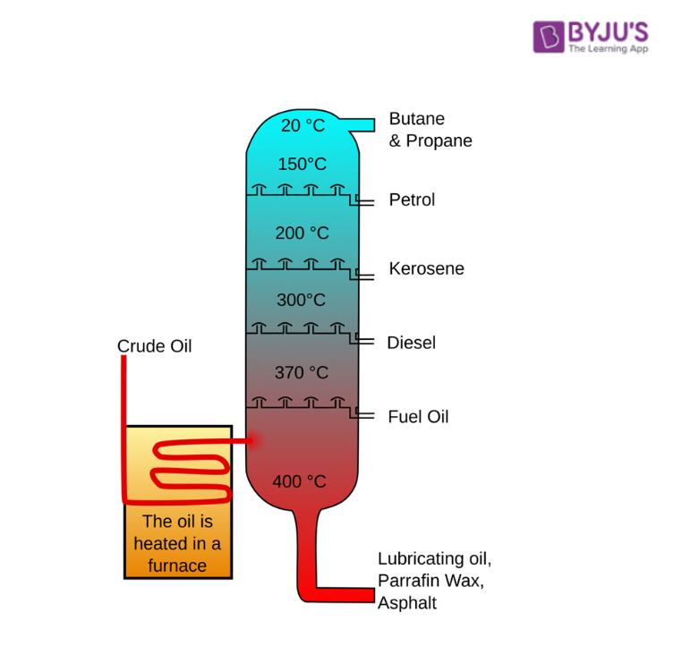

In industry, the refining process is generally called the “downstream” sector, while the “upstream” sector is known as the raw crude oil output. The word downstream is synonymous with the idea of sending oil down the supply chain of a commodity to an oil refinery to be refined into petrol. The downstream phase also includes the actual sale of petroleum products to other companies , governments or private individuals.

Uses of Petroleum

Refined products obtained from crude oil have a number of uses.

* + - * [Liquefied Petroleum Gas](https://byjus.com/chemistry/difference-between-cng-and-lpg/) or LPG is used in households as well as in the industry.
      * Diesel and petrol are used as fuels for vehicles. Diesel is generally preferred for heavy motor vehicles.
      * Petrol is also used as a solvent for dry cleaning, whereas diesel is also used to run electric generators.
      * Kerosene is used as a fuel for stoves and jet planes.
      * Lubricating oil reduces wear and tear and corrosion of machines.
      * Paraffin wax is used to make candles, ointments, ink, crayons, etc.
      * Bitumen or asphalt is mainly used to surface roads.

alkenes

## What are Alkenes?

The common family of hydrocarbons found in crude oil is alkenes. In this family there is at least one carbon–carbon double bond. This double bond makes a big difference to the chemistry of the compounds of the family.

Alkenes and particularly ethene are tremendously important in the chemical industry. They are not found in crude oil in very large quantities but are produced by the [cracking of the alkanes](https://byjus.com/chemistry/cracking-meaning/). The alkenes like all hydrocarbons, burn in air to form carbon dioxide and water. In oxygen ethene reacts explosively so it is not much good as a fuel. The alkenes are also too useful in the chemical industry for the manufacture of plastics and many other chemicals to be used as fuels.

General Properties of Alkenes

1. **Physical state**– The members containing two or four carbon atoms are gases, five to seventeen, liquids, eighteen onwards, solids at room temperature and they burn in air with a luminous smoky flame.
2. **Density –** Alkenes are lighter than water.
3. **Solubility –** Alkenes are insoluble in water and soluble in organic solvents such as benzene etc.
4. **Boiling point –** The boiling points of alkenes show a gradual increase with an increase in the molecular mass or chain length, this indicates that the intermolecular attractions become stronger with the increase in the size of the molecule.

Classification of Alkenes

Alkyl groups bonded to the sp2 hybridised carbon atoms of alkenes affect the stability of the double bond. The chemical reactivity of alkenes also is often affected by the number of alkyl groups bonded to the sp2 hybridised [carbon atoms](https://byjus.com/chemistry/carbon/). Thus, it is useful to classify alkenes by the number of alkyl groups attached to the C=C structural unit. This feature is called the degree of substitution.

An alkene that has a single alkyl group attached to the sp2 hybridised carbon atom of the double bond is monosubstituted. An alkene whose double bond is at the end of the chain of carbon atoms is also sometimes called a terminal alkene. Alkenes that have two, three and four alkyl groups bonded to the carbon atoms of the double bond are disubstituted, trisubstituted and tetrasubstituted respectively.

|  |  |
| --- | --- |
| monosubstituted | RCH=CH2 |
| Disubstituted | RCH=CHR or R2C=CH |
| Trisubstituted | R2C=CHR |
| tetrasubstituted | R2C=CR2 |

## Uses of Alkenes

The list of uses of various alkenes like ethene, propene etc., is given below.

* Manufacture of plastics like polythene for making buckets, bowls, bags etc.
* Manufacture of polystyrene used in making car battery cases and parts of the refrigerator.
* Making ethane-1,2-diol used as anti-freezing for motor car radiators.
* Manufacture of ethanol and synthetic fibre terylene.
* Making an anti-knock for car engines.
* Manufacture of plastic, polypropene for making ropes and packaging material.
* Manufacture of propanol used in making acetone.
* Manufacture of acrylic fibre

Alkanes

## What are Alkanes?

Alkanes are organic compounds that consist of single-bonded carbon and hydrogen atoms. The formula for Alkanes is CnH2n+2, subdivided into three groups – chain alkanes, cycloalkanes, and the branched alkanes.

## Alkane as saturated hydrocarbons

* Alkanes are a series of compounds that contain carbon and hydrogen atoms with single covalent bonds. These are known as saturated hydrocarbons. This group of compounds consists of carbon and hydrogen atoms with single covalent bonds. Also comprises a homologous series having a **molecular formula of CnH2n+2.**
* Alkanes are the simplest family of hydrocarbons. They contain only carbon and hydrogen. Each carbon atom forms four bonds and each hydrogen atom forms one bond. Chemists use line-angle formulas because they are easier and faster to draw than condensed structural formulas. Structural formulas for alkanes can be written in yet another condensed form.

The simple alkane methane contains one carbon atom and CH4 as its [molecular formula](https://byjus.com/chemistry/empirical-molecular-formula/). As this compound have just single covalent bonds only, therefore, its structural formula is

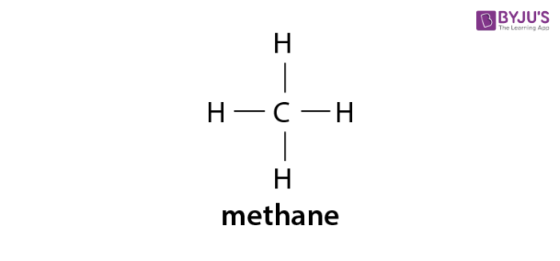

In a long chain alkane molecule, additional carbon atoms are attached to each other with the help of a single covalent bond. Each atom is attached to the sufficient hydrogen atoms to develop a total of four single covalent bonds. This long-chain structure is known as octane. An eight-carbon alkane has a molecular formula – C 8H 18 and structural formula-

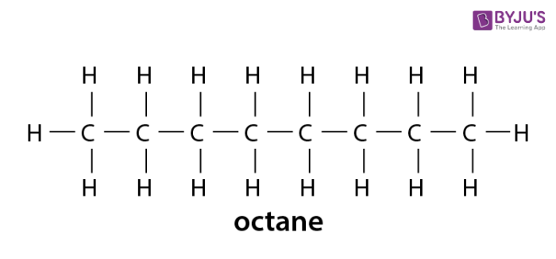

List of Alkanes and its structures

The list of some Alkanes with the molecular formula and structures are given below.​

|  |  |  |
| --- | --- | --- |
| **List of Alkanes** | **Molecular Formula** | **Structure** |
| Methane | (CH4) | Methane |
| Ethane | (C2H6) | Ethane |
| Propane | (C3H8) | Propane |
| Butane | (C4H10) | Butane |
| Pentane | (C5H12) | Pentane |
| Hexane | (C6H14) | Hexane |
| Heptane | (C7H16) | Heptane |
| Octane | (C8H18) | Octane |
| Nonane | (C9H20) | Nonane |
| Decane | (C10H22) | Decane |

Physical Properties of Alkanes

### 1. The Solubility of Alkanes

* Due to very little difference of electronegativity between carbon and hydrogen and covalent nature of C-C bond or C-H bond, alkanes are generally non-polar molecules.
* As we generally observe, polar molecules are soluble in polar solvents whereas non-polar molecules are soluble in non-polar solvents. Hence, alkanes are hydrophobic in nature that is, alkanes are insoluble in water.
* However, they are soluble in organic solvents as the energy required to overcome the existing Van Der Waals forces and generate new [Van Der Waals forces](https://byjus.com/chemistry/van-der-waals-forces/) is quite comparable.

### 2. The Boiling Point of Alkanes

* As the intermolecular Van Der Waals forces increase with the increase of the molecular size or the surface area of the molecule we observe:
* The boiling point of alkanes increases with increasing molecular weight,
* The straight-chain alkanes are observed to have a higher boiling point in comparison to their structural isomers.

### 3. The Melting Point of Alkanes

* The melting point of alkanes follow the same trend as their boiling point that is, it increases with increase in molecular weight.
* This is attributed to the fact that higher alkanes are solids and it’s difficult to overcome intermolecular forces of attraction between them.
* It is generally observed that even-numbered alkanes have a higher trend in melting point in comparison to odd-numbered alkanes as the even-numbered alkanes pack well in the solid phase, forming a well-organized structure which is difficult to break.

Alkanes Formula and its Condensed Structures

Structural formulas for alkanes can be written in condensed form. For example, the structural formula of pentane contains three CH2 methylene groups in the middle of the chain. We can group them together and write the structural formula. The first five alkanes formulas with an unbranched chain are tabulated below.

|  |  |  |
| --- | --- | --- |
| **Name** | **Molecular formula of alkane** | **Condensed structural formula of alkane** |
| methane | CH4 | CH4 |
| ethane | C2H6 | CH3CH3 |
| propane | C3H8 | CH3CH2CH3 |
| butane | C4H10 | CH3(CH2)2CH3 |
| pentane | C5H12 | CH3(CH2)3CH3 |

An abbreviated way to draw structural formulas in which each vertex and line terminus represents a carbon atom and each line represents a bond.

Alkane Formula Chemistry

Formulas of organic compounds present information at several levels of sophistication. [Molecular formulas](https://byjus.com/chemistry/chemical-formula/), such as that of octane give the number of each kind of atom in a molecule of a compound. The molecular formula of C8H18 may apply to several alkanes, each one of which has unique chemical, physical and toxicological properties. These different compounds are designated by structural formulas showing the order in which the atoms in a molecule are arranged. Compounds that have the same molecular, but different structural formulas are called structural isomers.

Most organic compounds can be derived from alkanes. In addition, many important parts of organic molecules contain one or more alkane groups, minus a hydrogen atom, bonded as substituents onto the basic organic molecule. As a consequence of these factors, the names of many organic compounds are based on alkanes.

Branched Chain Alkane Formula

As with other organic compounds, the carbon atoms in alkanes may form straight chains, branched chains, or rings. These three kinds of alkanes are straight chain alkanes, branched chain alkanes and [cycloalkanes](https://byjus.com/chemistry/cycloalkanes/). The general molecular formula of alkane for straight and branched-chain alkanes is CnH2n+2 and that of cyclic alkanes is CnH2n.

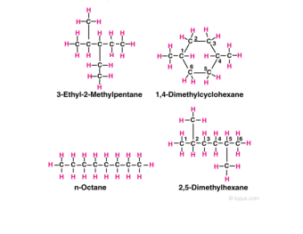

For example in the diagram, the four hydrocarbon molecules contain 8 carbon atoms each. In one of the molecules, all the carbon atoms are in a straight chain and in two they are in branched chains, whereas in a fourth, 6 of the carbon atoms are in a ring.

Alkyl Groups

When a substituent like halogen bonds to an alkane molecule, one carbon-hydrogen bond of the molecule gets converted to a carbon-substituent bond. It can be understood with an example- A new compound known as [chloromethane](https://byjus.com/chemistry/dichloromethane/) is formed when methane reacts with chlorine. The new compound is composed of a CH3 group that is bonded to a chlorine atom.

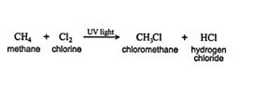

When an alkane having hydrogen is removed from one bond, it is called an alkyl group. This Alkyl group is often denoted by the letter R the same as halogens represent by the letter X. Here is a methane‐chlorine reaction that can be generalized as

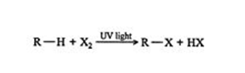

Biogas

Biogas is a renewable energy source produced by the breakdown of organic matter by certain bacteria under anaerobic conditions. It is a mixture of methane, hydrogen, and carbon dioxide. It can be produced by agricultural waste, food waste, animal dung, manure, and sewage. The process of biogas production is also known as anaerobic digestion.

Biogas recycles the waste products naturally and converts them into useful energy, thereby, preventing any pollution caused by the waste in the landfills, and cutting down the effect of the toxic chemicals released from the [sewage treatment](https://byjus.com/biology/sewage-treatment/)plants.

Biogas converts the harmful methane gas produced during decomposition, into less harmful carbon dioxide gas.

The organic material decomposes only in a wet environment. The organic matter or the waste dissolves in water and forms a sludge which is rich in nutrients and used as a fertilizer.

Biogas Plant

The biogas production is carried out in anaerobic digesters known as Biogas plant. These have five components:

* An inlet to feed the slurry
* The fermentation chamber where the biogas is produced with the activity of microorganisms,
* The gas storage tank to store the gas produced,
* The outlet for the used slurry,
* The exit pipe for removing the gas produced.

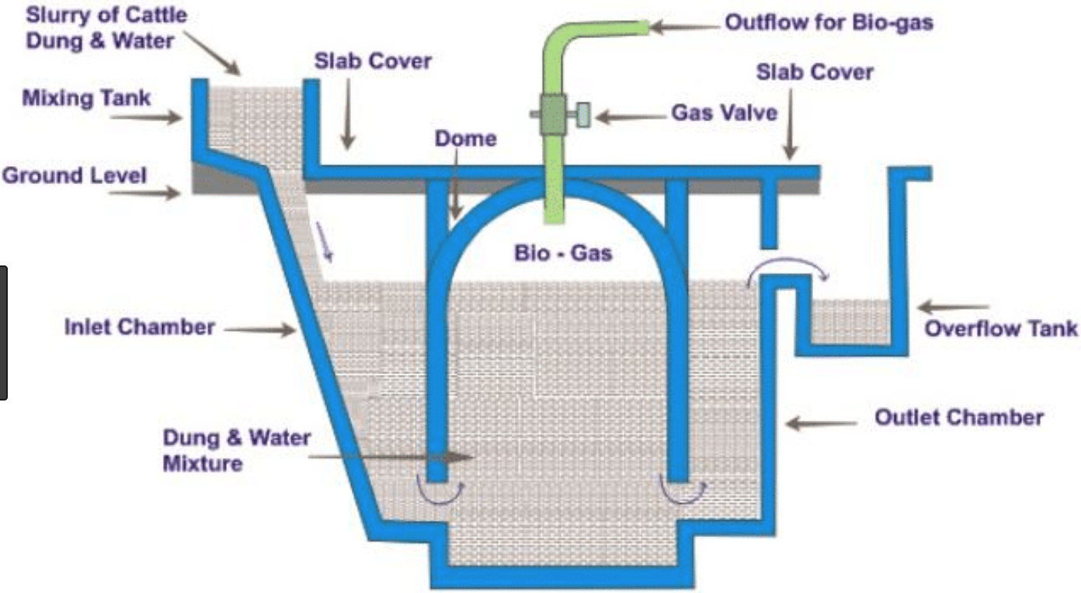

Biogas digester

The organic matter if fed into the digesters which are completely submerged in water to provide it with an anaerobic environment. These digesters are hence called anaerobic digesters. The microorganisms breakdown the organic matter and convert it into biogas.

The biogas thus produced is supplied to the respective places through the exit pipes.

### Breakdown of Organic matter

1. The first stage involves the breakdown of organic polymers, such as carbohydrates, making it available to the next stage of bacteria known as the acidogenic bacteria.
2. The acidogenic bacteria then convert the sugar and amino acids into carbon dioxide, ammonia, hydrogen, and organic acids.
3. The organic acids are now converted into acetic acid, hydrogen, ammonia, and carbon dioxide.
4. These are finally converted into methane and carbon dioxid
5. e by the action of methanogens.

Methane is a combustible gas, i.e., it can be burnt. This gas is supplied to various places and is used in cooking and lighting. It is an eco-friendly gas and reduces various environmental problems like, it reduces the reliance on fossil fuels.

Polymers

## What are Polymers?

A polymer is a large molecule or a macromolecule which essentially is a combination of many subunits. The term polymer in Greek means ‘many parts’. Polymers can be found all around us. From the strand of our DNA, which is a naturally occurring biopolymer, to polypropylene which is used throughout the world as plastic.

Polymers may be naturally found in plants and animals (**natural polymers**) or may be man-made (**synthetic polymers**). Different polymers have a number of unique physical and chemical properties, due to which they find usage in everyday life.

Classification of Polymers

Polymers cannot be classified under one category because of their complex structures, different behaviours and vast applications. We can, therefore, classify polymers based on the following considerations.

### Classification of Polymers based on the Source of Availability

There are **three types of classification**under this category, namely, Natural, Synthetic, and Semi-synthetic Polymers.

#### Natural Polymers:

They occur naturally and are found in plants and animals. For example, proteins, starch, cellulose, and rubber. To add up, we also have biodegradable polymers called biopolymers.

#### Semi-synthetic Polymers:

They are derived from naturally occurring polymers and undergo further chemical modification. For example, cellulose nitrate, and cellulose acetate.

#### Synthetic Polymers:

These are man-made polymers. Plastic is the most common and widely used synthetic polymer. It is used in industries and various dairy products. For example, nylon-6, 6, polyether’s etc.

Also Read: [Natural Polymers vs Synthetic Polymers](https://byjus.com/chemistry/differentiate-natural-polymers-from-synthetic-polymers-and-properties/)

#### Classification Based on Polymerization

* **Addition Polymerization:**For Example, poly ethane, Teflon, Polyvinyl chloride (PVC)
* **Condensation Polymerization:** Example, Nylon -6, 6, perylene, polyesters.

Structure of Polymers

Most of the polymers around us are made up of a **hydrocarbon backbone**. A [Hydrocarbon](https://byjus.com/jee/hydrocarbons/) backbone is a long chain of linked carbon and hydrogen atoms, possible due to the tetravalent nature of carbon.

A few examples of a hydrocarbon backbone polymer are polypropylene, polybutylene, and polystyrene. Also, there are polymers which, instead of carbon, have other elements in their backbone. For example, Nylon, contains nitrogen atoms in the repeated unit backbone.

Types of Polymers

On the basis of the type of the backbone chain, polymers can be divided into:

* **Organic Polymers**: Carbon backbone.
* **Inorganic Polymers**: Backbone constituted by elements other than carbon.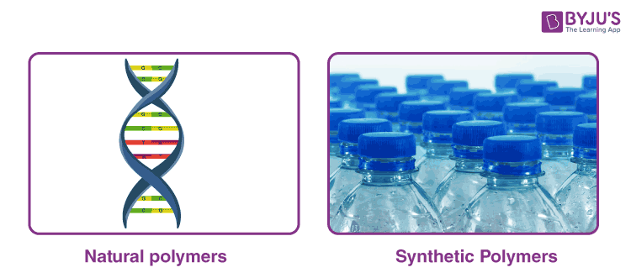

On the basis of their synthesis:

* [Natural Polymers](https://byjus.com/chemistry/natural-polymers/)
* [Synthetic Polymers](https://byjus.com/chemistry/synthetic-polymers/)

### Biodegradable Polymers

The polymers which are degraded and decayed by microorganisms like bacteria are known as **biodegradable polymers**. These types of polymers are used in surgical bandages, capsule coatings and in surgery. For example, Poly hydroxybutyrate co vel [PHBV]

### High-Temperature Polymers

These polymers are stable at high temperatures. Due to their [high molecular weight](https://byjus.com/molecular-weight-formula/), these are not destroyed even at very high temperatures. They are extensively used in the healthcare industries, for making sterilization equipment and in the manufacturing of heat and shock-resistant objects.

**Few of the important polymers are:**

**Polypropylene**: It is a type of polymer that softens beyond a specific temperature allowing it to be moulded, and on cooling, it solidifies. Due to its ability to be easily moulded into various shapes, it has a lot of applications.

A few of which are in stationary equipment’s, automotive components, reusable container speakers and much more. Due to its relatively low energy surface, the polymer is fused with the welding process and not using glue.

**Polyethene**: It is the most common type of [plastic](https://byjus.com/chemistry/plastics/) found around us. Mostly used in packaging from plastic bags to plastic bottles. There are different types of polyethene, but their common formula is (C2H4)n.

Properties of Polymers

### Physical Properties

* As chain length and cross-linking increase, the tensile strength of the polymer increases.
* Polymers do not melt, and they change state from crystalline to semi-crystalline.

### Chemical Properties

* Compared to conventional molecules with different side molecules, the polymer is enabled by hydrogen bonding and ionic bonding resulting in better cross-linking strength.
* Dipole-dipole bonding side chains enable the polymer for high flexibility.
* Polymers with [Van der Waals forces](https://byjus.com/chemistry/van-der-waals-forces/) linking chains are known to be weak but give the polymer a low melting point.

### Optical Properties

* Due to their ability to change their refractive index with temperature, as in the case of PMMA and HEMA: MMA, they are used in lasers for applications in spectroscopy and analytical applications.

## Some Polymers and their Monomers

* Polypropene, also known as polypropylene, is made up of monomer propene.
* Polystyrene is an aromatic polymer, naturally transparent, made up of monomer styrene.
* Polyvinyl chloride (PVC) is a plastic polymer made of monomer vinyl chloride.
* The urea-formaldehyde resin is a non-transparent plastic obtained by heating formaldehyde and urea.
* Glyptal is made up of monomers ethylene glycol and phthalic acid.
* Bakelite or polyoxybenzylmethylenglycolanhydride is a plastic which is made up of monomers phenol and aldehyde.

Types of Polymerization Reactions

### Addition Polymerization

This is also called as chain growth polymerization. In this, small monomer units join to form a giant polymer. In each step, the length of the chain increases. For example, Polymerization of [ethane](https://byjus.com/chemistry/ethane/) in the presence of Peroxides

### Condensation Polymerization

In this type small molecules like H2O, CO, NH3 are eliminated during polymerization (step growth polymerization). Generally, organic compounds containing bifunctional groups such as idols, -dials, diamines, dicarboxylic acids undergo this type of polymerization reaction. For example, Preparation of nylon -6, 6

Uses of Polymers

Here we will list some of the important uses of polymers in our everyday life.

* Polypropene finds usage in a broad range of industries such as textiles, packaging, stationery, plastics, aircraft, construction, rope, toys, etc.
* Polystyrene is one of the most common plastic actively used in the packaging industry. Bottles, toys, containers, trays, disposable glasses and plates, tv cabinets and lids are some of the daily-used products made up of polystyrene. It is also used as an insulator.
* The most important use of polyvinyl chloride is the manufacture of sewage pipes. It is also used as an insulator in electric cables.
* Polyvinyl chloride is used in clothing and furniture and has recently become popular for the construction of doors and windows as well. It is also used in vinyl flooring.
* Urea-formaldehyde resins are used for making adhesives, moulds, laminated sheets, unbreakable containers, etc.
* Glyptal is used for making paints, coatings, and lacquers.
* Bakelite is used for making electrical switches, kitchen products, toys, jewellery, firearms, insulators, computer discs, etc.

Commercial Uses of Polymers

|  |  |  |
| --- | --- | --- |
| **Polymer** | **Monomer** | **Uses of Polymer** |
| **Rubber** | Isoprene (1, 2-methyl 1 – 1, 3-butadiene) | Making tyres, elastic materials |
| **BUNA – S** | (a) 1, 3-butadiene (b) Styrene | Synthetic rubber |
| **BUNA – N** | (a) 1, 3-butadiene (b) Vinyl Cyanide | Synthetic rubber |
| **Teflon** | Tetra Fluoro Ethane | Non-stick cookware – plastics |
| **Terylene** | (a) Ethylene glycol (b) Terephthalic acid | Fabric |
| **Glyptal** | (a) Ethylene glycol (b) Phthalic acid | Fabric |
| **Bakelite** | (a) Phenol (b) Formaldehyde | Plastic switches, Mugs, buckets |
| **PVC** | Vinyl Cyanide | Tubes, Pipes |
| **Melamine Formaldehyde Resin** | (a) Melamine (b) Formaldehyde | Ceramic plastic material |
| **Nylon-6** | Caprolactam | Fabric |

Ethanol

Ethanol formula is given here along with its structure. Ethanol, ***also known as ethyl alcohol*** is simple alcohol and is generally found in alcoholic beverages. Ethyl alcohol or [ethanol](https://byjus.com/chemistry/ethanol/) is also represented as **EtOH**. The formula for ethanol and its structure is simple and is mentioned below with explanations.

What is the Formula for Ethyl Alcohol or Ethanol?

The formula for ethyl alcohol or ethanol is C2H5OH or CH3CH2OH.

Ethanol is a compound of carbon, hydrogen and oxygen elements was described by Antoine Lavoisier and its chemical formula was determined by Nicolas-Theodore de Saussure in 1808. Five years later, Archibald Scott Couper published the structural formula of ethanol.

Ethyl alcohol consists of two carbon chains, i.e. ethane which has a [hydroxyl group](https://byjus.com/chemistry/alcohol-structure-hydroxyl-group/) (-OH) group attached to it. The proper ethyl alcohol (ethanol) chemical formula and structural formula re given in the following points.

Ethyl Alcohol- Chemical Formula

Ethanol has 2 carbon atoms, 5 hydrogen atoms, and an OH group. The chemical formula of ethanol is given by-

|  |  |
| --- | --- |
| **Chemical Formula for Ethanol (Ethyl Alcohol)** | C2H5OH |
| **Formula for Ethyl Alcohol** | CH3CH2OH |

Ethyl alcohol is a colourless, volatile liquid with a characteristic odour and a pungent taste. It has a flashpoint of 55°F, is classified as a depressant drug, and is toxic when ingested in large quantities.

The molecular formula describes the composition of ethanol molecules two carbon atoms, six hydrogen atoms and one atom of oxygen occur per molecule but gives us no structural information. Structural information is how the atoms are connected and how the molecule fills the space.

Ethyl Alcohol Structural Formula

The carbon atoms in an ethanol molecule are sp3 hybridized, i.e. they have a free rotation. It is the second most simple alcohol and is represented as-

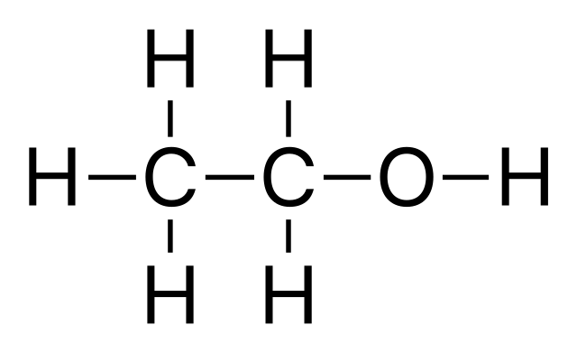

There are various uses of ethanol and the most common one is in the pharmaceutical industry where it is used as an antiseptic. Apart from that, ethyl alcohol is also used in cosmetics, and in biotechnological industries. Click [uses of methanol and ethanol](https://byjus.com/chemistry/uses-of-methanol-and-ethanol/) to learn more about its uses in everyday life.

Uses of Ethanol

* + - * Ethanol is used in alcoholic beverages, solvents, scents, flavourings, colouring, medicines, chemical synthesis, and thermometers.
      * Ethanol is used as a fuel, an excellent solvent and an important raw material for making other chemicals.  
        Pure ethanol is a toxic liquid, methanol which is even more toxic, is sometimes added to it to put off anyone wanting to drink it.
      * A mixture of ethanol and methanol is known as methylated spirits or sometimes ‘meths’ used in camping stoves.
      * Used as a raw material for making esters which in turn are used as solvents in food flavouring, and in the manufacture of cosmetics.
      * Vinegar, a weak solution of ethanoic acid, is produced from ethanol by a biochemical process. It involves oxidation caused by bacteria called acetobacter

How is ethanol made?

The input material for making ethanol is called **feedstock**. Different ethanol production facilities use different feedstock. Facilities in Ontario and Quebec mainly use corn kernels. Facilities in Western Canada mainly use wheat kernels. This is due to the geographical distribution of corn and wheat agriculture in Canada.

The processes are basically the same for corn, wheat and other types of feedstock. Let’s use corn as an example feedstock.

There are six main steps in the ethanol production process.

Steps in the ethanol production process

Infographic - Text Version

1. **Milling**: Whole corn kernels are ground into a form of flour, or **meal**. The meal is mainly starch. A **starch**is a **carbohydrate**made up of long chains of sugar molecules.
2. **Liquefaction**: Water is added to the meal to make ‘slurry.’ The slurry is heated to break the long starch molecules into smaller pieces. The **enzyme** alpha-amylase is added to **catalyze**(or speed up) the breakdown of the starch molecules.
3. **Saccharification**: Starch molecule pieces are broken down into the simple sugar **glucose**. This reaction is catalyzed by an enzyme called glucoamylase.
4. **Fermentation**: Single-celled microorganisms called **yeast**are added to the slurry. Fermentation is the biochemical process that occurs when yeast break down glucose. Yeast gets energy from glucose. As a result, ethanol is produced.
5. **Distillation and Dehydration**: The product of the fermentation process is only 10-15% ethanol. It must be **concentrated**to become pure (100%) ethanol. Ethanol has a lower **boiling point** than water. It is selectively **evaporated**and **condensed**in a process called **distillation**. This process produces ethanol that is 95% pure. The remaining 5% of the mixture is water. The mixture is strained and **dehydrated**to produce pure ethanol.
6. **Denaturation**: A small amount of gasoline is added to fuel ethanol to make it undrinkable.

There are two main byproducts of corn ethanol production: **carbon dioxide (CO2)** and distillers’ grains. CO2 is produced by yeast as a byproduct of the fermentation reaction. It is often released into the atmosphere. But it can also be captured and used for other purposes. For example:

* making carbonated beverages
* producing **dry ice** (frozen CO2) to use for cold storage
* supporting photosynthesis in vegetable greenhouses

Distillers’ grains are the residue from the fermentation tanks. They contain all the non-fermentable components of the corn kernels, plus the added yeast. Distillers’ grains are valuable as a high-protein ingredient in **livestock feed**.

Ethanol is blended with the gasoline used in our vehicles to produce a more environmentally friendly fuel. The majority of vehicles manufactured after the 1980s can run on a blend of gasoline made up of 10% ethanol (E10).

Ethanol is a **renewable resource**. That’s why governments around the world are encouraging people to use ethanol instead of **fossil fuels**. In Canada, the federal government has a set of guidelines called the [Clean Fuel Standards](https://www.canada.ca/en/environment-climate-change/services/managing-pollution/energy-production/fuel-regulations/clean-fuel-standard/regulatory-approach.html). It encourages people to use fuels with a higher mix of ethanol.

Some people, on the other hand, have [concerns about using ethanol as fuel](https://letstalkscience.ca/educational-resources/stem-in-context/what-are-pros-and-cons-ethanol-biofuel). For example, there are worries about the amount of energy and land required to grow ethanol feedstock crops. Even with these concerns, ethanol-based fuel is still an important alternative to fossil fuels!

What are Soaps and Detergents?

### Soaps

* Soaps are potassium or sodium salts of a [carboxylic acid](https://byjus.com/chemistry/carboxylic-acid-properties/) having a long aliphatic chain attached to it.
* They are surfactants (compounds that reduce the surface tension between a liquid and another substance) and therefore help in the emulsification of oils in water.
* Soaps are generally prepared via the saponification of fats and oils.
* The carboxylate end of the soap molecule is hydrophilic whereas the hydrocarbon tail is hydrophobic.

### Detergents

* Detergents are the potassium or sodium salts of a long alkyl chain ending with a sulfonate group.
* They are soluble in [hard water](https://byjus.com/jee/hardness-of-water-types-and-removal/).
* This solubility is attributed to the fact that the sulfonate group does not attach itself to the ions present in hard water.
* Commonly, anionic detergents such as alkyl benzene sulfonates are used for domestic purposes.

Difference between Soap and Detergent

The key differences between soaps and detergents are tabulated below.

|  |  |
| --- | --- |
| **Difference Between Soap and Detergent** | |
| **Soaps** | **Detergents** |
| Consist of a ‘-COONa’ group attached to a fatty acid having a long alkyl chain. | Consist of a ‘-SO3Na’ group attached to a long alkyl chain. |
| They are not effective in hard water and saline water | They do not lose their effectiveness in hard water and saline water. |
| Soaps are completely biodegradable | Detergents containing a branched hydrocarbon chain are non-biodegradable |
| They have a tendency to form scum in a hard water environment. | These compounds do not form scum. |
| They are derived from natural sources such as vegetable oils and animal fats. | Detergents are synthetic derivatives. |
| Soaps are environment-friendly products since they are biodegradable. | These compounds can form a thick foam that causes the death of aquatic life. |
| Examples of soaps: sodium palmitate and sodium stearate. | Examples of detergents: deoxycholic acid and sodium lauryl sulfate. |

Preparation of Soap

The most commonly used soap making process is the [saponification](https://byjus.com/chemistry/saponification/) of oils and fats.

This process involves heating oils and fats reacting them with a liquid alkali to produce soap plus water plus glycerine.

### Saponification

The other soap making process is the neutralization of fatty acids with an alkali. Oils and fats are hydrolyzed with high-pressure steam to yield glycerine and crude fatty acids.

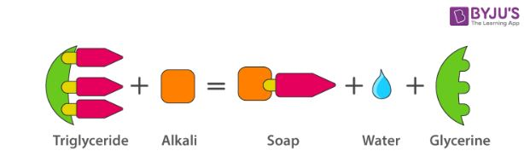

Saponification

The fatty acids are later purified by the method of [distillation](https://byjus.com/chemistry/distillation/) and neutralized with an alkali to produce water and soap.

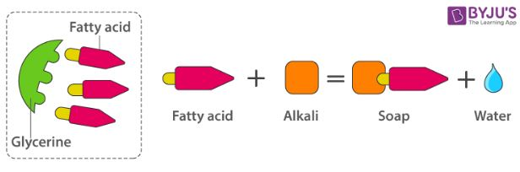

Preparation of Soap

Alkali like sodium hydroxide produces sodium soap which is hard. Potassium soaps are soft. They are used in shaving creams and some liquid hand soaps.

The carboxylate end of the soap molecule is a hydrophilic end. The grease and oil attract the hydrocarbon chain and repel water. This is known as the hydrophobic end.

Cleansing Action of Soaps and Detergents

Most of the dirt is oily in nature and oil does not dissolve in water. The molecule of soap constitutes sodium or potassium salts of long-chain carboxylic acids. In the case of soaps, the carbon chain dissolves in oil and the ionic end dissolves in water. Thus, the soap molecules form structures called [micelles](https://byjus.com/chemistry/micelle/). In micelles, one end is towards the oil droplet and the other end which is the ionic faces outside. Therefore, it forms an emulsion in water and helps in dissolving the dirt when we wash our clothes.

Soap is a kind of molecule in which both the ends have different properties.

* ***Hydrophilic end***
* ***Hydrophobic end***

The first one is the hydrophilic end which dissolves water and is attracted to it whereas the second one is the hydrophobic end that is dissolved in hydrocarbons and is water repulsive in nature. If on the surface of the water, soap is present then the hydrophobic tail which is not soluble in water will align along the water surface.

### Micelles

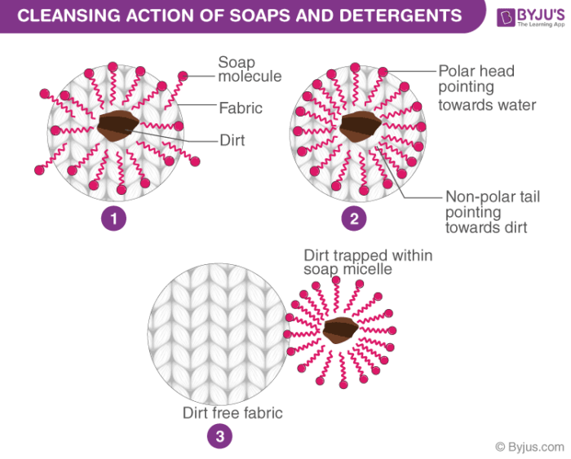

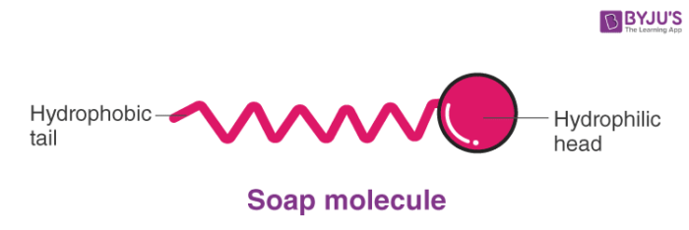

In water, the soap molecule is uniquely oriented which helps to keep the hydrocarbon part outside the water. When the clusters of molecules are formed then hydrophobic tail comes at the interior of the cluster and the ionic end comes at the surface of the cluster and this formation is called a micelle. When the soap is in the form of micelles then it has the ability to clean the oily dirt which gets accumulated at the centre. These micelles remain as [colloidal solutions](https://byjus.com/jee/colloids/). Therefore, the dirt from the cloth is easily washed away. The soap solution appears cloudy as it forms a colloidal solution which scatters light.

Advantages of Soap :  
(i)   Soap is cheaper and readily available.  
(ii)  It works well for cleaning of clothes with soft water (water which does not contain Ca2+ and Mg2+)  
(iii) Soaps are 100% biodegradable, i.e., decomposed by micro-organisms present in sewage, therefore, they do not create water pollution.  
Disadvantages of Soap :  
(i) It does not work well with hard water containing Ca2+ or Mg2+. It reacts with Ca2+ and Mg2+ to form white precipitate which is called scum and soap goes waste. The reaction which takes place is a follows.  
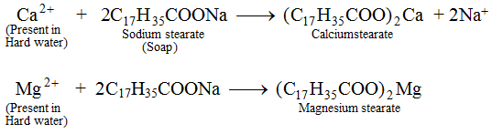  
Thus, soap solution forms less lather with hard water.  
(ii)  Soap is not suitable for washing woolen garments because it is basic in nature and woolen garments have acidic dyes.  
(iii) Soap are less effective in saline water and acidic water.

Detergents may be used in saline or acidic water  
(iii) Detergents are more easily soluble in water than soaps.  
(iv) Detergents can be used for washing woolen garments whereas soaps cannot be used.  
(v)  Detergents having linear hydrocarbon chain are biodegradable.  
**Disadvantages of Detergents over Soaps :**  
(i) Synthetic detergents having branched hydrocarbon chain are not fully biodegradable, i.e., they are not decomposed by micro-organisms in sewage and create water pollution.  
(ii)  They are more expensive than soaps.

Carboxylic Acids as a group of carbon compounds

## What is Carboxylic Acid?

A Carboxylic Acid is an organic compound containing a carboxyl functional group. They occur widely in nature and are also synthetically manufactured by humans. Upon deprotonation, carboxylic acids yield a ***carboxylate anion with the general formula R-COO–***, which can form a variety of useful salts such as soaps.

Definition

The carboxylic acids are the ***most important functional group that present C=O***. This type of organic compounds can be obtained by different routes, some carboxylic acids, such as [citric acid](https://byjus.com/chemistry/citric-acid/), lactic acid or fumaric acid are produced by fermentation, most of these types of carboxylic acids are applied in the food industry.

Carboxylic Acid Structure

The ***general formula of a carboxylic acid is R-COOH***, where COOH refers to the carboxyl group, and R refers to the rest of the molecule to which this group is attached. In this carboxyl group, there exists a carbon which shares a double bond with an oxygen atom and a single bond with a hydroxyl group.

A carboxylic acid’s general formula is R-COOH, where COOH denotes the carboxyl group and R denotes the remainder of the molecule to which this group is linked. There is a carbon in this carboxyl group that has a double connection with an oxygen atom and a single bond with a hydroxyl group.

The first four carboxylic acids derived from alkanes are methanoic acid (HCOOH), ethanoic acid (CH3COOH), propanoic acid (C2H5COOH), and butanoic acid (C3H7COOH).

The general structure of a carboxylic acid is illustrated below.

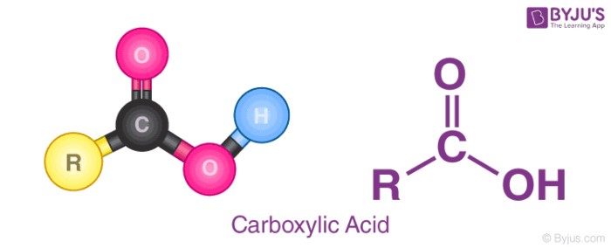

From the illustration provided above, it can be observed that a carboxylic acid contains a hydroxyl group attached to a carbonyl carbon. Due to the electronegativity of the oxygen atom, this functional group can undergo ionization and discharge a proton.

The carboxylate ion, produced from the removal of a [proton](https://byjus.com/chemistry/protons/) from the carboxyl group, is stabilized by the presence of two oxygen atoms (through which the negative charge can move). Some common examples of carboxylic acids include acetic acid (a component of vinegar) and Formic acid.

Nomenclature of Carboxylic Acids

Generally, these organic compounds are referred to by their trivial names, which contain the suffix “-ic acid”. An example of a ***trivial name for a carboxylic acid is acetic acid (CH3COOH)***. In the IUPAC nomenclature of these compounds, the suffix **“-oic acid”** is assigned.

The guidelines that must be followed in the IUPAC nomenclature of carboxylic acids are listed below.

* The suffix “e” in the name of the corresponding alkane is replaced with “oic acid”.
* When the aliphatic chain contains only one carboxyl group, the carboxylic carbon is always numbered one. For example, CH3COOH is named as ethanoic acid.
* When the aliphatic chain contains more than one carboxyl group, the total number of carbon atoms is counted and the number of carboxyl groups is represented by Greek numeral prefixes such as “di-”, “tri-“, etc.
* A carboxylic acid is named by adding these prefixes and suffixes to the parent alkyl chain. Arabic numerals are used for indicating the positions of the carboxyl group.
* The name “carboxylic acid” or “carboxy” can also be assigned for a carboxyl substituent on a carbon chain. An example of such nomenclature is the name 2-carboxyfuran for the compound 2-Furoic acid.

Carboxylic Acid Examples

Some examples describing the nomenclature of carboxylic acids as per IUPAC guidelines are provided below.

|  |  |
| --- | --- |
| **Trivial Name and Formula** | **IUPAC Name of the Carboxylic Acid** |
| [Formic acid](https://byjus.com/formic-acid-formula/), H-COOH | Methanoic acid |
| Crotonic acid, CH3CH=CH-COOH | But-2-enoic acid |
| Carbonic acid, OH-COOH | Carbonic acid |
| Butyric acid, CH3(CH2)2COOH | Butanoic acid |

Properties of Carboxylic Acids

Most of the properties of carboxylic acids are a result of the presence of the [carboxyl group](https://byjus.com/chemistry/carboxyl-group/). Some physical and chemical properties of these compounds are discussed in this subsection.

### 1. Physical Properties of Carboxylic Acids

* ***Carboxylic acid molecules are polar due to the presence of two electronegative oxygen atoms.***
* They also participate in hydrogen bonding due to the presence of the carbonyl group (C=O) and the hydroxyl group.
* When placed in nonpolar solvents, these compounds form ***dimers via hydrogen bonding*** between the hydroxyl group of one carboxylic acid and the carbonyl group of the other.  
  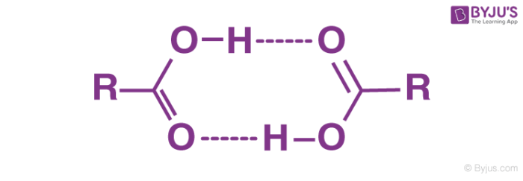
* The solubility of compounds containing the carboxyl functional group in water depends on the size of the compound. The smaller the compound (the shorter the R group), the higher the solubility.
* The boiling point of a carboxylic acid is generally higher than that of water.
* These compounds have the ability to donate protons and are therefore ***Bronsted-Lowry acids.***
* They generally have a strong sour smell. However, their esters have pleasant odours and are therefore used in perfumes.

### 2. Chemical Properties of Carboxylic Acids

* The ***α-carbon belonging to a carboxylic acid can easily be halogenated via the***[***Hell-Volhard-Zelinsky reaction***](https://byjus.com/chemistry/hell-volhard-zelinsky-reaction-mechanism/)***.***
* These compounds can be converted into amines using the Schmidt reaction.
* A carboxylic acid can be reduced to an alcohol by treating it with hydrogen to cause a hydrogenation reaction.
* Upon reaction with alcohols, these compounds yield esters.

## Uses of Carboxylic Acids

* Fatty acids that are essential to human beings are made up of carboxylic acids. Examples include omega-6 and [omega-3 fatty acids](https://byjus.com/chemistry/omega-3-fatty-acids/).
* Higher fatty acids are also used in the ***manufacture of soaps***.
* The production of soft drinks and many other food products involves the use of many carboxylic acids.
* The manufacture of rubber involves the use of acetic acid as a ***coagulant.***
* Hexanedioic acid is used in the ***manufacture of nylon-6,6***.
* Carboxylic acids have numerous applications in the rubber, textile, and leather industries.
* Ethylenediaminetetraacetic acid is a widely used ***chelating agent.***
* The synthesis of many drugs involves the use of these compounds. Therefore, carboxylic acids are very important in ***pharmaceuticals***.
* The production of many polymers involves the use of compounds containing the carboxyl functional group.

Alcohol as a group of carbon compounds

Alcohols are those organic compounds which are characterized by the presence of one, two or more ***hydroxyl groups (−OH)*** that are attached to the carbon atom in an alkyl group or hydrocarbon chain.

These alcohols are considered to be as the derivatives of water where one among the hydrogen atoms are replaced by alkyl group, which is typically represented by the letter R in an organic structure. Alcohol also comes in different structures and forms.

Alcohols are known to be one among most of the commonly occurring [organic compounds](https://byjus.com/chemistry/nomenclature-of-organic-compounds/). These are utilized in the form of sweeteners, preparation of perfumes, and sometimes in the process of synthesizing other compounds, wherein some others are abundantly manufactured in organic chemicals coming in various industries.

Main Types of Alcohols

Alcohols are differentiated based upon the presence of the hydroxyl group attached. The location of this hydroxyl group as well will change the physical and chemical properties of any alcohol.

There are three types of alcohol. Alcohols are classified as **primary, secondary or tertiary alcohols.**

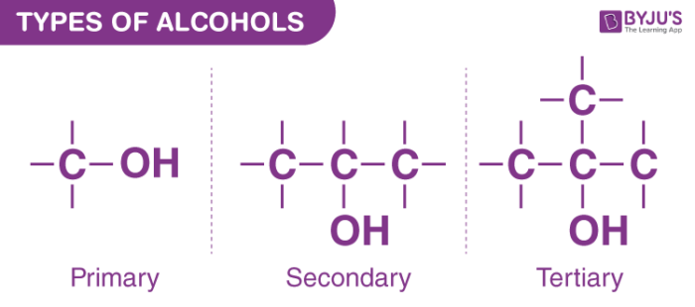

Types of Alcohols

The classification is done in accordance with the carbon atom of an alkyl group is attached to the [hydroxyl group](https://byjus.com/chemistry/alcohol-structure-hydroxyl-group/). Most of the alcohols are known to be colourless liquids or even are said to behave as solid at room temperatures. Alcohols with less molecular weight are said to be highly soluble in water; and with their increase in molecular weight, they tend to become less soluble and their vapour pressures, boiling points, densities, and the viscosities to increase.

***types of alcohols.***

## 1. Primary Alcohols

Primary alcohols are those alcohols where the carbon atom of the hydroxyl group (OH) is attached to only one single alkyl group. Some examples of these primary alcohols include Methanol (propanol), ethanol, etc. The complexity of this alkyl chain is unrelated to the classification of any alcohol considered as primary. The existence of only one linkage among –OH group and an alkyl group and the thing that qualifies any alcohol as a primary.

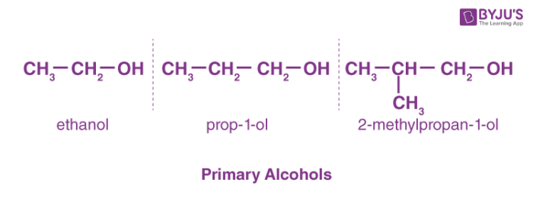

Primary Alcohols

## 2. Secondary Alcohols

Secondary alcohols are those where the carbon atom of the hydroxyl group is attached to two alkyl groups on either side. The two alkyl groups present may be either structurally identical or even different. Some examples of secondary alcohols are given below.

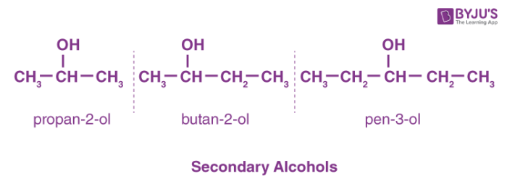

Secondary Alcohols

## 3. Tertiary Alcohols

Tertiary alcohols are those which feature a hydroxyl group attached to the carbon atom which is connected to 3- alkyl groups. The physical properties of these alcohols mainly depend on their structure. The presence of this -OH group allows the alcohols in the formation of hydrogen bonds with their neighbouring atoms. The bonds formed are weak, and this bond makes the boiling points of alcohols higher than its alkanes. Examples of tertiary alcohols include-

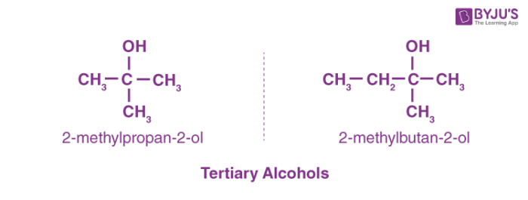

Uses of Alcohols

There are several uses of alcohols. Some are listed below.

* Alcohols are consumed as ***beverages*** where the alcohols specifically consist of 30–40 per cent of ethanol by volume.
* These are used as an ***anti-freezing agent*** with a mixture of a solution containing ethylene glycol dissolved in water.
* Alcohol ethanol is used as an ***antiseptic agent***.
* Some alcohols are used as ***fuels*** in internal combustion engines like the methanol.
* In the field of medicine, a few of them are used as **preservatives** for the specimens in laboratories.